

**Name: Abdul Basit**

**Registration No: 5027**

**Department: BSSE**

**Teacher: SIR Zain Ul Islam Adil**

**Subject: Modern Programming Language**

Assignment No 01

**Table of Content**

**1 Introduction……………………………………………………………………………………**

**2 Project Name………………………………………………………………………………….**

**3 Language…………………………………………………………………………………………**

**4 Basic Function…………………………………………………………………………………**

**5 Output…………………………………………………………………………………………….**

**Introduction**

Basic Calculator using Java language which performing basics mathematics operations (+, -, *, /).

**Project Name**

Calculator

**Language**

Java

**Basic Function**

* (sum)

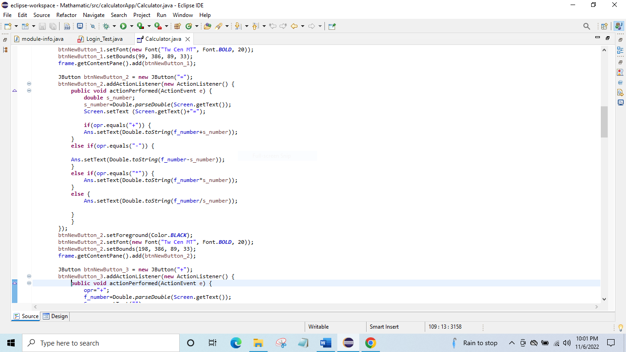

* (Subtract)



* (product)



* (Division)



**Output**

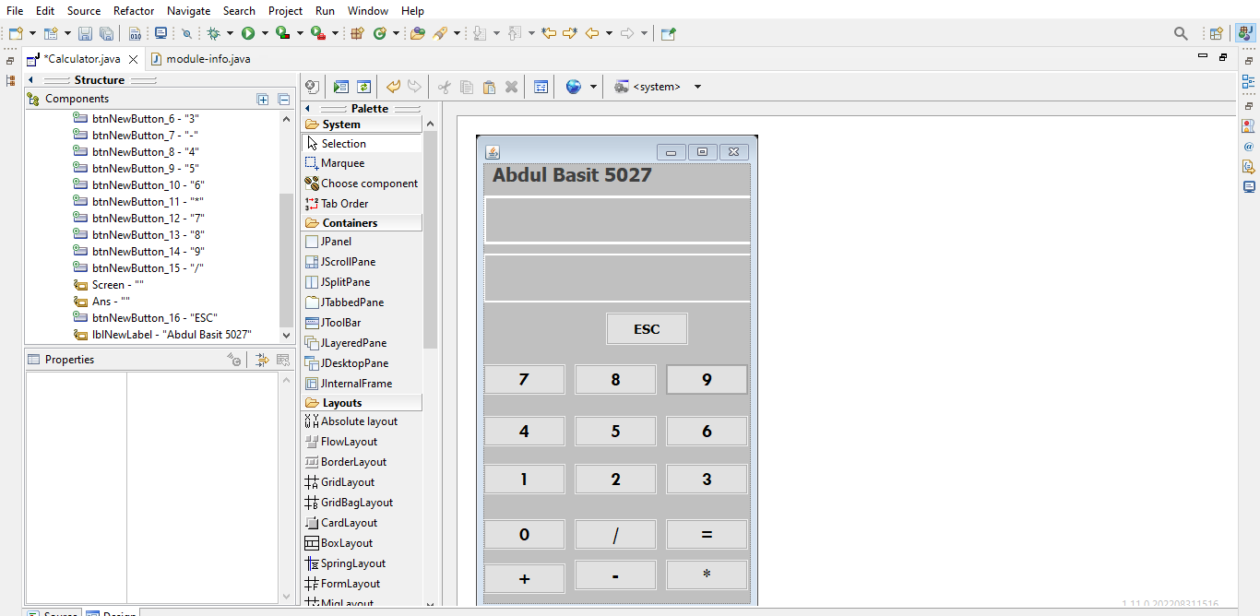

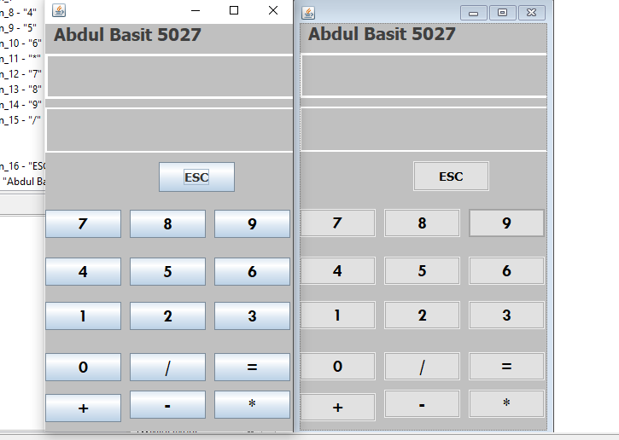

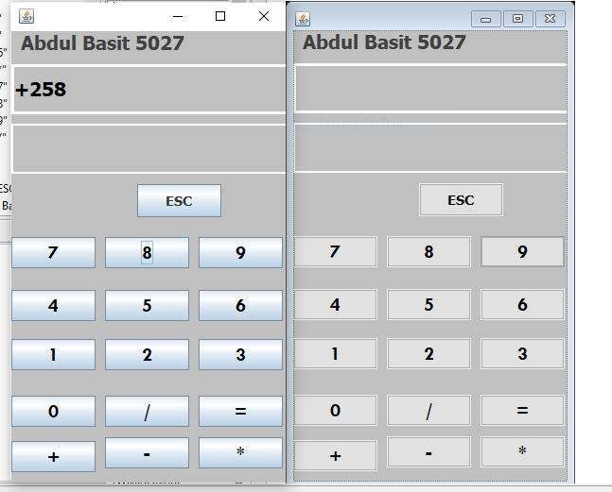

**Description : In my calculator we perform addition , subtraction , multiplication and division. Here we can add ,sub, multiple and divide two or more number.**

**Github link:**

**https://github.com/Abdulbasit451/Assignment1.git**

**END**